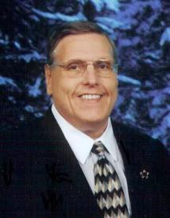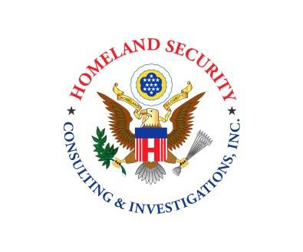
BIOGRAPHY

Jeffrey H. James
Starting in law enforcement 38 years ago, Jeff quickly began utilizing his aptitude as a leader and was promoted quickly to the first of many supervisory & management roles he would hold over the years.

Today, Jeff is the Chairman & Founder of Homeland Security Consulting & Investigations, Inc. He was the former President & CEO of K A R D Protection Group, Inc. until its sale.

Jeff is widely considered to be an industry expert. Jeff holds the highest designation (Certified in Homeland Security Level V) available from The American Board for Certification in Homeland Security. And was appointed by the board’s executive committee to Fellow status, which has been awarded to very few other security and public safety professionals in the country. On Behalf of ABCHS Jeff sits on the Illinois Board for Security and Public Safety Executives. Jeff is both a State of Illinois Licensed Private Detective and a Licensed Private Security Contractor. Jeff is also licensed as a Private Investigator in Arizona. Jeff also holds the CBRNE certification (Chemical, Biological, Radiological, and Nuclear Explosives)

Jeff is a Past Chairman of the Board of Directors of the Associated Detectives and Security Agencies of Illinois and is a proud member of the National Association of Chiefs of Police, National Council of Investigative & Security Services, Illinois Security Chiefs Association, Illinois Police Association and The American College of Forensic Examiners International as well as The Chicago Crime Commission

